**Answer Key**

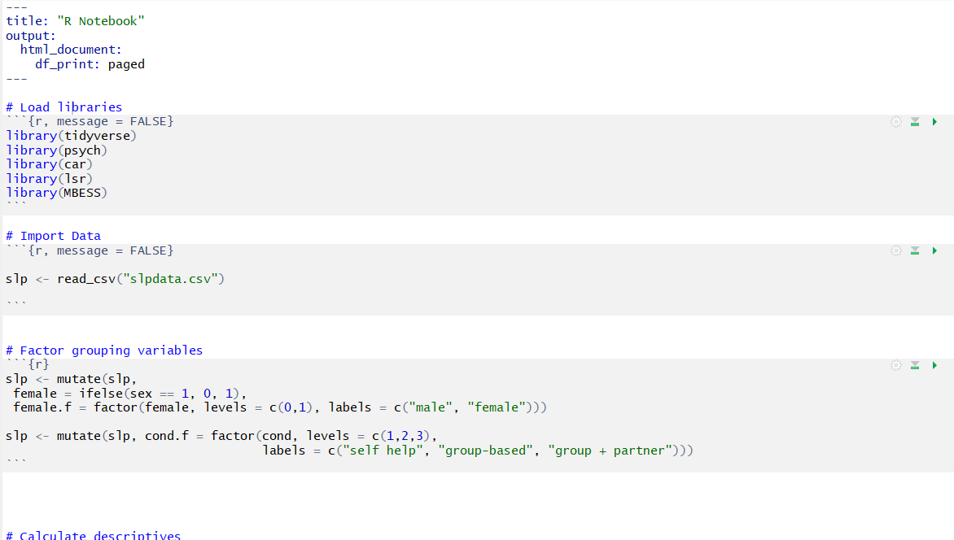

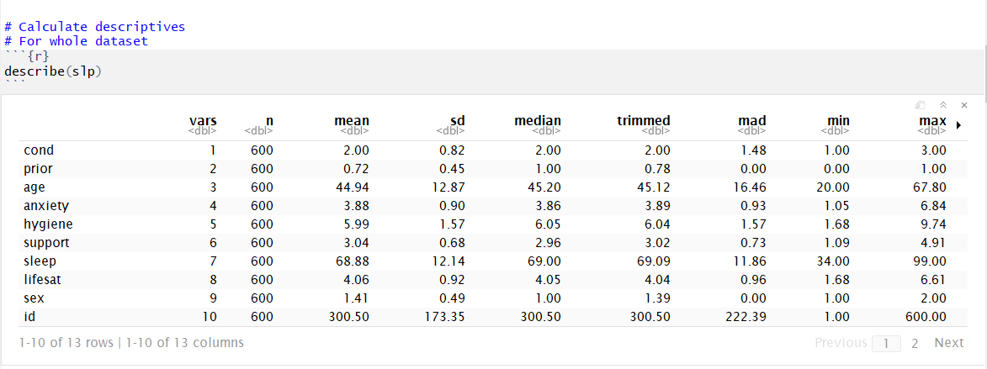

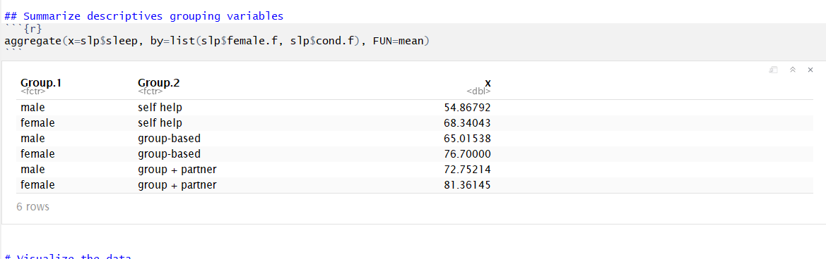

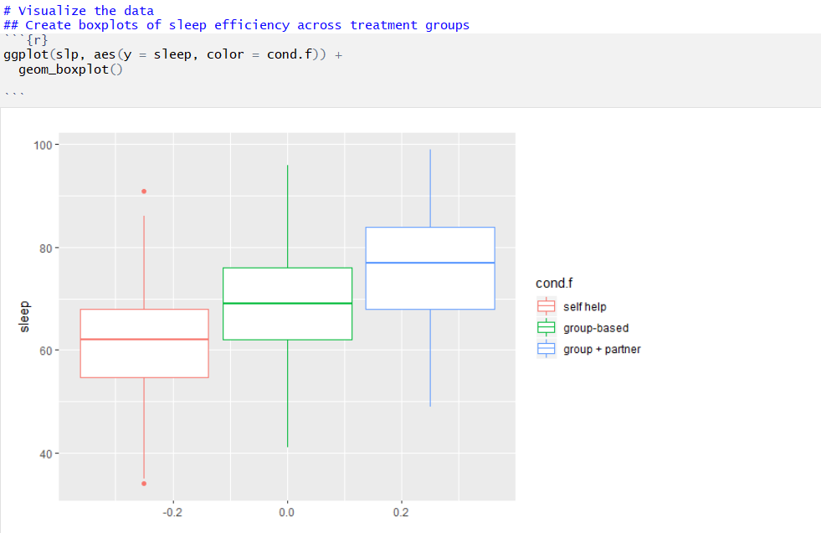

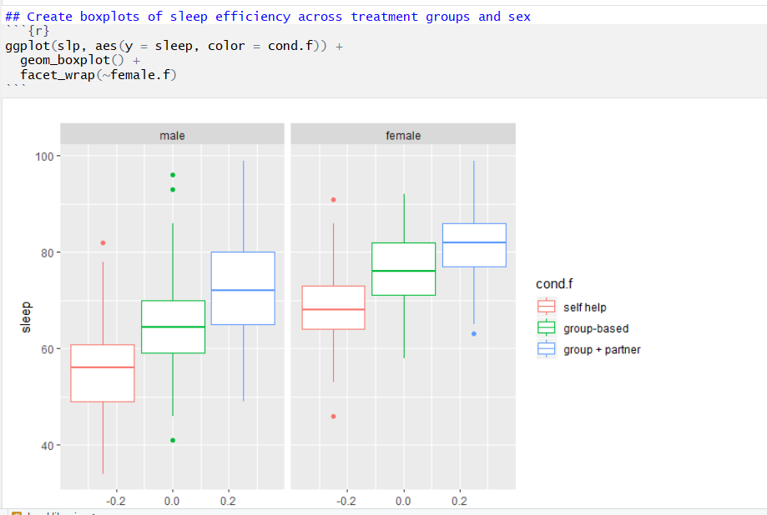

**The faceted boxplot tells us that the group + partner condition experiences the highest scores on sleep for both genders. However, females seem to have higher sleep scores as compared to males.**

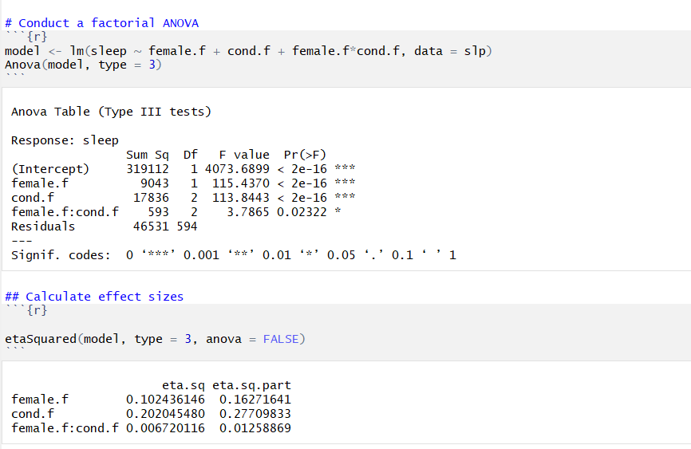

b.) In the white space, interpret the η2 and partial η2 values for each main effect and the interaction effect.

**The η2 is the effect of the variable on the entire variance of the outcome. Therefore, female, explains 10% of the variance in sleep, condition explains 20% of the variance in sleep and the interaction of the two explains <1% of the variance in sleep.**

**The partial η2 is the effect of the variable on the outcome *after* partialling out the variance from the other variables in our model. Therefore, female explains 16% of the partialled out variance in sleep, condition explains 28% of the partialled variance in sleep and the interaction of female and condition explains 1% of the partialled variance in sleep.**

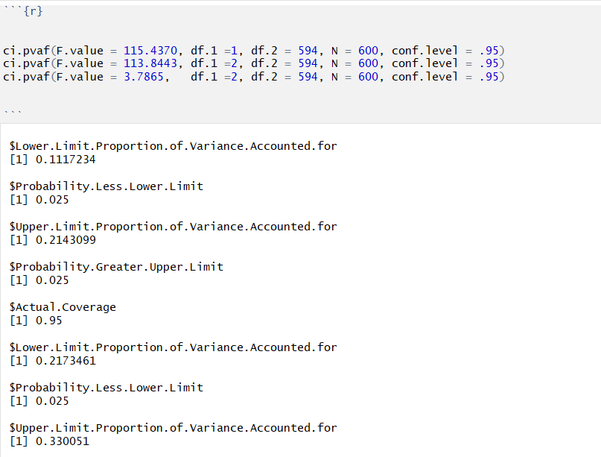

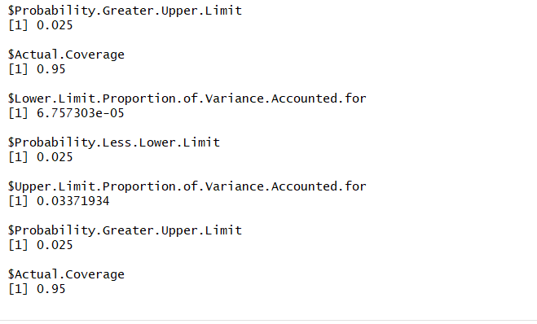

**Each of the eta squared confidence intervals tell us the range of plausible values of the partial eta squared. If we ran this experiment 100 times, 95% of our results would likely fall within the range of these values.**

**Female: Partial η2 = .16, 95% CI = [.11, .21]**

**Condition: Partial η2 = .28, 95% CI = [.22, .33]**

**Interaction: Partial η2 = .01, 95% CI = [<.01, .03]**